Java Package

A **java package** is a group of similar types of classes, interfaces and sub-packages.

Package in java can be categorized in two form, built-in package and user-defined package.

There are many built-in packages such as java, lang, awt, javax, swing, net, io, util, sql etc.

Here, we will have the detailed learning of creating and using user-defined packages.

**Advantage of Java Package**

1) Java package is used to categorize the classes and interfaces so that they can be easily maintained.

2) Java package provides access protection.

3) Java package removes naming collision.

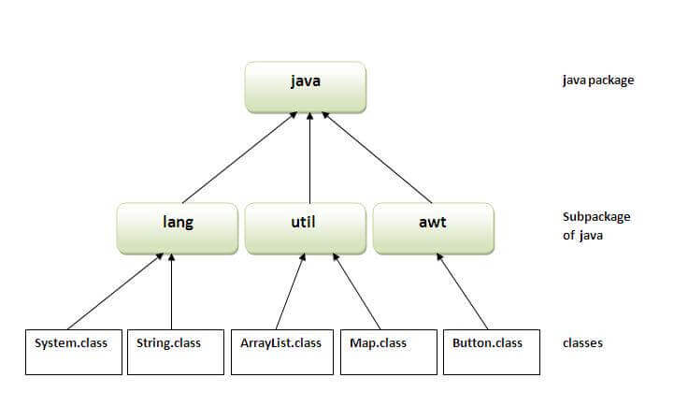

**How to access package from another package?**

There are three ways to access the package from outside the package.

* import package.*;
* import package.classname;
* fully qualified name.